**A PROJECT REPORT**

**ON**

**Paradise Resort**



**Submitted To: Project Members:**

Ms. Ramsha Khalid Maham Zafar(2025-CS-182)

**Course Instructor Name:** Areeba Aleem(2025-CS-183)

Usman Ashfaq Ahsan Mustafa (2025-CS-197)

Muhammad Furqan(2025-CS-187)

Laiba Naeem(2025-CS-215)

**Date:** 05/01/2026

**1. Executive Summary**

This project involves designing and publishing a Holiday Resort website using HTML and CSS. The website provides information about the resort, packages, and contact details in a clean and user-friendly way. GitHub was used for version control, and the website was deployed using GitHub Pages. All supporting documents and data are based on the same website to maintain consistency.

## 2. Project Objectives & Scope

The objective of this project is to design a responsive and informative resort website. The website includes pages such as Home, About, Gallery, Packages, and Contact. The project focuses on front-end design using HTML and CSS, without backend functionality.

### **Site Structure**

The website is structured into multiple well-organized pages, each serving a specific purpose. The Home page provides the first impression of the resort. The About page explains the resort’s background and goals. The Gallery page displays images of rooms and facilities. The Packages page shows available offers and pricing, while the Book Now page allows users to select room details. The Contact page enables users to send inquiries.

Figure: Shows the home page of website

Figure: Shows the booking page of website

## Figure: Shows the contact page of website

## 

## 

## Figure: Shows the footer of website

### **Navigation**

The website uses a fixed and transparent navigation bar that appears on all pages. The navigation menu includes links to Home, About, Gallery, Packages, Contact, and a Book Now button for quick access. The navigation design is simple and user-friendly, allowing smooth movement between pages. It is also responsive and works properly on different screen sizes, including mobile devices.



## Figure: Shows the transparent navigation bar of website

## Figure: Shows the mobile view transparent navigation bar of website

## Design Choices

### **Fonts**

The website uses

* Marcellus
* Lato

as primary fonts.

* Times New Roman
* Segoe UI

are also used in some sections for readability.

### **Colors**

A blue theme is used throughout the website. Additional colors include

* #FBFBFC
* #555
* #8B0000
* #e0b527
* #3096CE

### **Layout Design**

### Flexbox is used for most layouts, while CSS Grid is used on the Gallery page. The layout is responsive and structured.

## 

## 

## Figure: shows mobile view gallery layout

## Assets Used

Images and background visuals were taken from

* Pexels
* Wallhaven
* Vecteezy

The website logo was designed using Canva. Most content was created by the project team, with some design inspiration taken from online templates.

## How to Run / Publish the Website

The website can be run locally by opening the index.html file in a browser. GitHub was used to store the project files, and GitHub Pages was used to publish the live website.

It was published on the GitHub Pages:

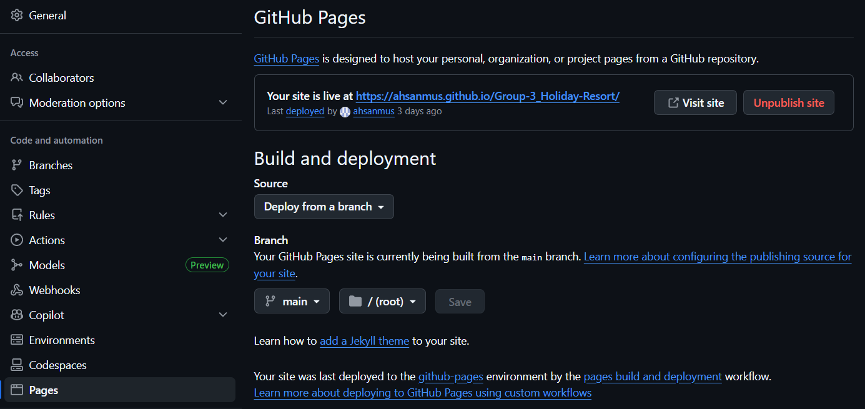

**Project GitHub Repository**

**Figure: Shows** GitHub repository showing project files and version control history

## Excel Data Usage

Excel was used to store data related to resort packages, including prices and details. Charts were created to compare package offerings and support analysis.

**Figure :** Excel chart comparing seasonal revenue in summer and winter

**Figure:** Shows excel chart showing profit and operating expense distribution

**How It Connects**

The website acts as the main source of information for the entire project. The same package names, prices, and details displayed on the website are used in the Excel file for data organization and analysis, and later presented in the presentation slides. Screenshots and the live website URL are included in this report to clearly show that all project components are connected and based on the same data.

**Figure:** Packages page showing resort offers and pricing used for Excel and presentation

**Reflection**

This project helped us understand how a complete website is planned, designed, and published. We learned how to structure web pages using HTML, apply styling and layouts using CSS, and manage project files using GitHub. The project also improved our skills in documentation, teamwork, and presenting technical work in an organized.

**Website Live Preview Link**

<https://ahsanmus.github.io/Group-3_Holiday-Resort/>

**GitHub Link**

<https://github.com/ahsanmus/Group-3_Holiday-Resort/tree/main>

**LinkedIn Post Screenshots**